**DR. AMBEDKAR COLLEGE, DEEKSHABHOOMI, NAGPUR**

**DEPARTMENT OF LAW**

**Academic Session - 2024-2025**

|  |  |
| --- | --- |
| **NAME OF THE PROGRAMME:** | “Sensitization of students regarding Anti ragging policy of the college by senior students-THE BUDDY SYSTEM” |
| **NAME OF THE PROGRAMME CO-ORDINATOR:** | Prof. Dr. Sandhya Kalamdhad  Dr. Vaishali A. Sukhdeve |
| **DATE AND DAY:** | 25th September 2024 at 10.30 AM. |
| **VENUE:** | Room no. 1- Main Building, Dr. Ambedkar College, Deekshabhoomi, Nagpur. |

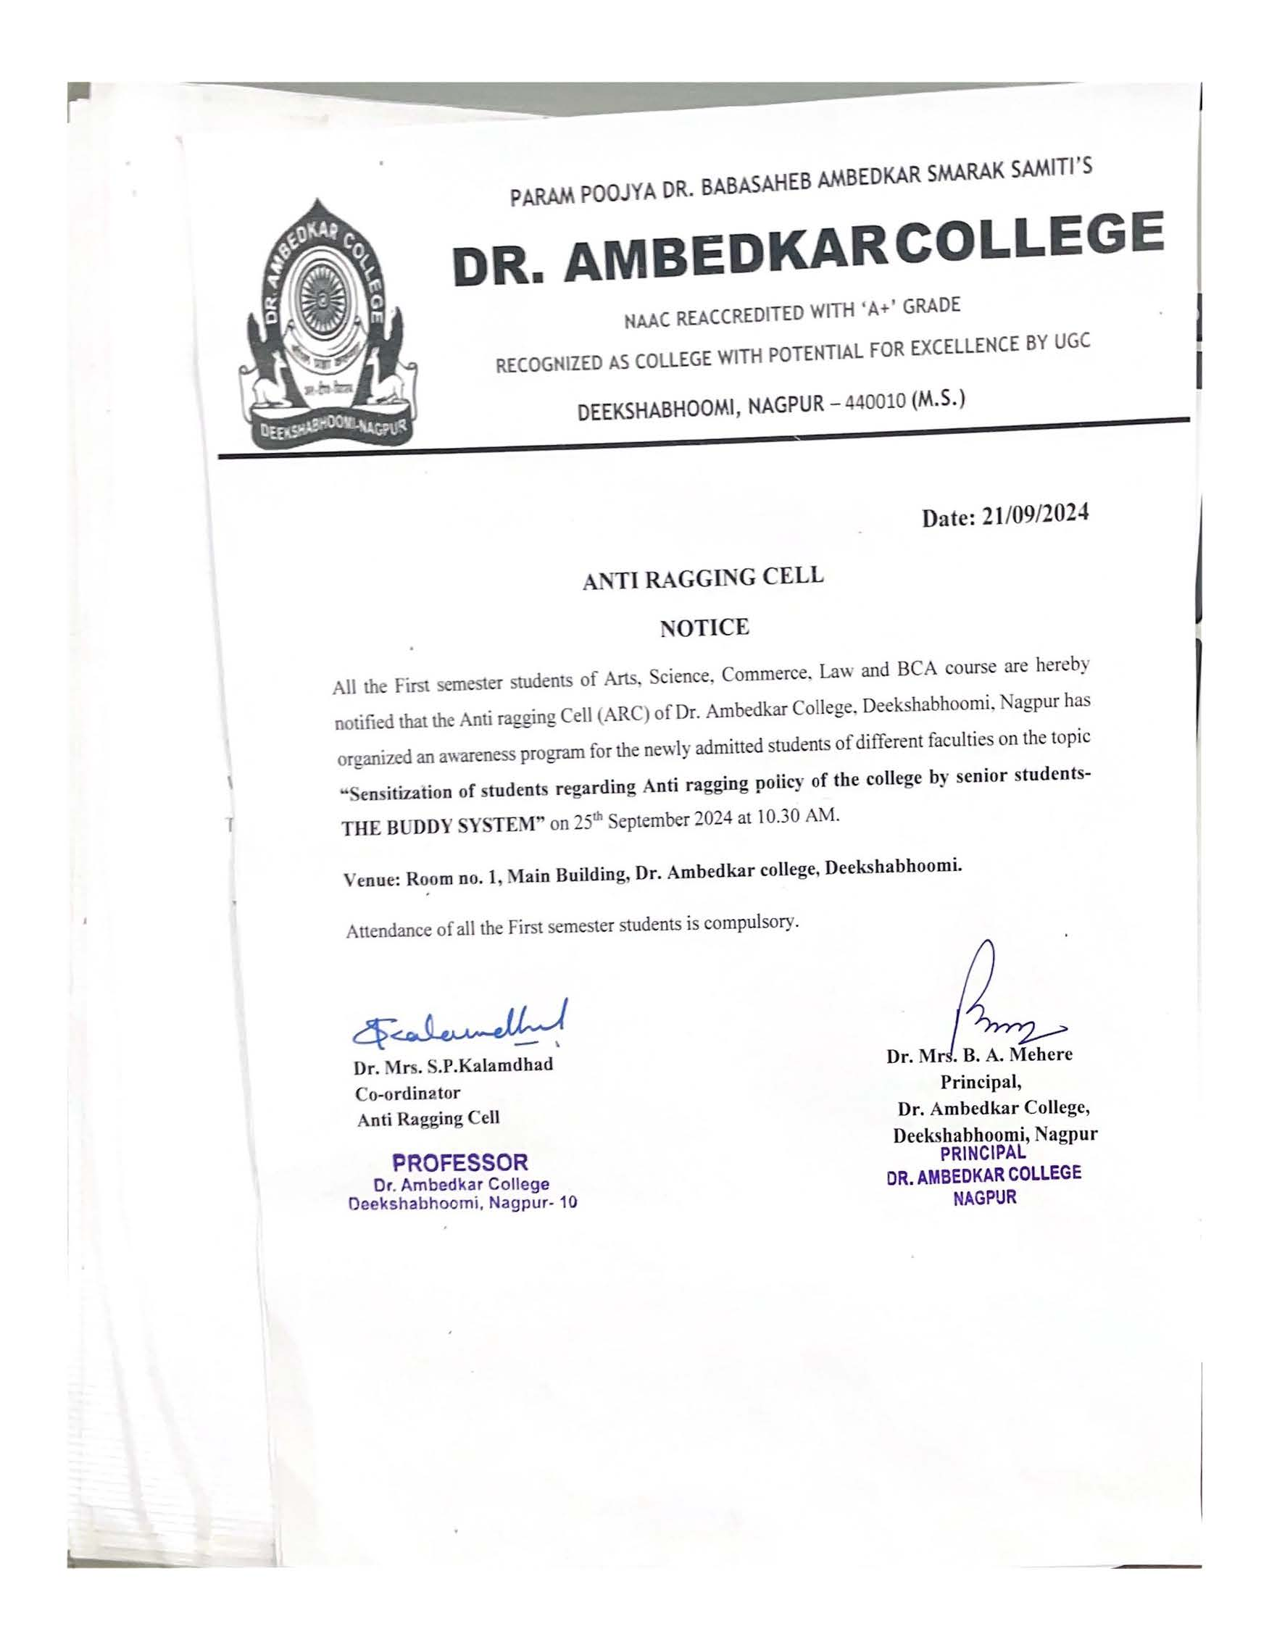

Anti Ragging Cell of Dr. Ambedkar College, Deekshabhoomi, Nagpur has organised an anti-ragging awareness program on the topic “Sensitization of students regarding Anti ragging policy of the college by senior students-THE BUDDY SYSTEM”. This program was organized with the objective to sensitize the newly admitted students of Arts, Commerce, Science, Law and BCA about zero tolerance regarding ragging practices in college.

The program was graced by the Principal, Dr. B.A.Mehere, and Dr. Mrs. S.P.Kalamdhad, Co-ordinator of Anti ragging Cell, Dr. Dhanashree Borikar, and Dr. Mrs. V.A. Sukhdeve, members of the Anti-ragging Cell were prominently present. Approximately 100 newly admitted students of different department attended the awareness program.

The program started with offering the tribute to two stalwarts of humanities, Lord Gautam Buddha and Dr. Babasaheb Ambedkar. Dr. Mrs. B.A. Mehere, Principal of the College delivered the welcome address where she guaranteed the students that the institution is zero tolerant towards the ragging practices and is instrumental in resolving these issues through Anti ragging Cell. The Anti-Ragging Cell ensures that the college complies with all relevant laws and regulations.

Dr. Mrs. S.P.Kalamdhad, Co-ordinator of Anti ragging Cell explained the students about the role, composition and functioning of the Anti-ragging cell. She elaborated how, Anti-Ragging Cell works to prevent ragging, by informing students about the issue and related punishments, and by creating a disciplined environment. The Anti-Ragging Cell investigates complaints about ragging and acts against those found guilty. The Anti-Ragging Cell monitors the performance of the Anti-Ragging Squad, which keeps a vigil and stops ragging incidents.

Another important feature of the Anti-ragging cell is the Buddy System. In this system the students of higher classes guide the newly admitted students about the rules and regulations of anti-ragging through numerous modes like interaction in classes, canteen, college premises etc.

Through this program, the senior students educated the newly admitted students about the nuances as well as repercussions about ragging, through 4 different skits. All the 4 different skits exhibited the different instances of ragging in college premises. Through these skits, student explained the UGC rules, regulations and punishments inflicted for ragging practices as mentioned in the existing legal enactment.

As an extension of Buddy system practice, our senior law students interacted with the newly admitted students in the canteen on the various issues of ragging practice. All these students were very much overwhelmed with such activity of the senior students and appreciated all their efforts.

The program was co-coordinated by Dr. Vaishali A. Sukhdeve, under the guidance and supervision of Dr. S.P. Kalamdhad. The senior Final year students involved in buddy system were Ms. Sanika Duragkar, Ms. Stuti Salodkar, Ms, Sakshi Rathi and all other 15 students from B.A.LLB 3rd sem 5 years course.

|  |  |
| --- | --- |
|  | |
| DR. SANDHYA KALAMDHAD, CO-ORDINATOR OF ANTI RAGGING CELL ADRESSING THE NEWLY ADMITTED STUDENTS | |
|  |  |
| GLIMPSES OF SKITS PERFORMED BY SENIOR LAW STUDENTS | |
|  |  |
| SENIOR STUDENTS INTERACTING WITH THE NEWLY ADMITTED STUDENTS AT COLLEGE PREMISES ESPECIALLY CANTEEN | |

